**AWS Database Migration Service (DMS)**

* AWS DMS is a cloud service that makes it easy to migrate relational databases, data warehouses, NoSQL databases.
* Using AWS DMS, we can perform one-time migration or replicate ongoing changes to keep sources and targets in sync
* If you want to migrate to a different database engine, AWS provides AWS Schema Conversion Tool (AWS SCT)
* DMS Architecture  
  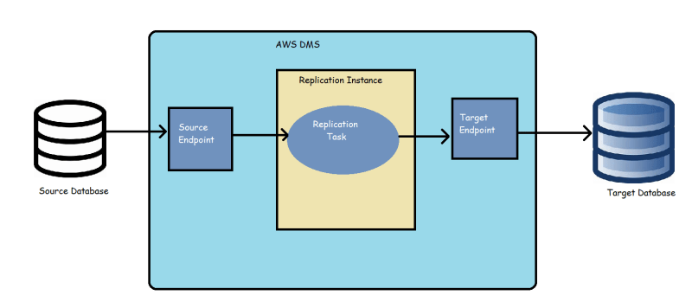
* Source Endpoint is connection to the source database
* Target Endpoint is connection to the target database
* When you configure DMS, you would configure replication, Which is performed by an Replication Instance (Which in turn is a database)

**Target Database**

* Lets create an AWS mysql RDS instance with db instance size db.t2.micro (free tier)  
  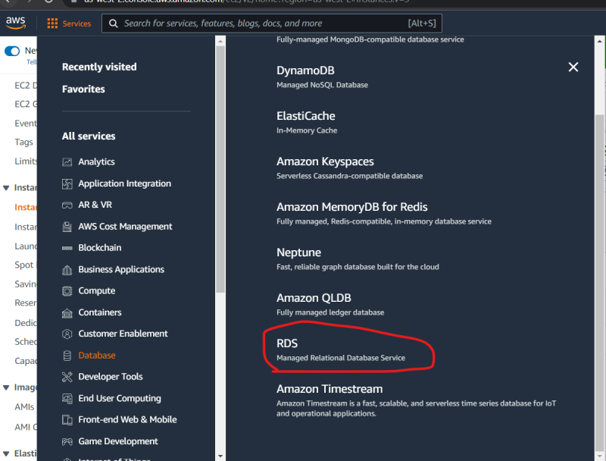  
  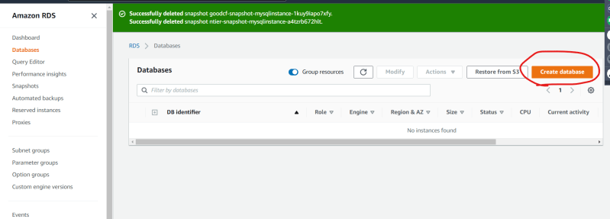  
  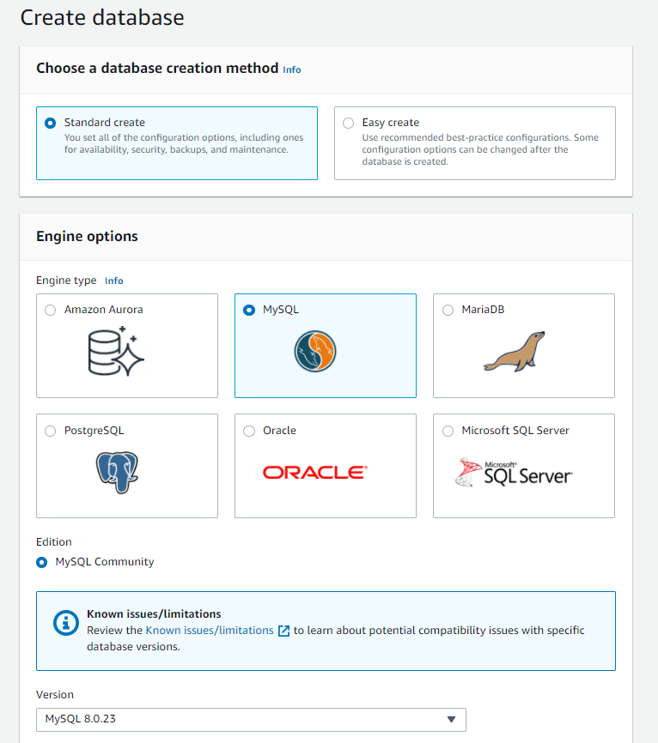  
  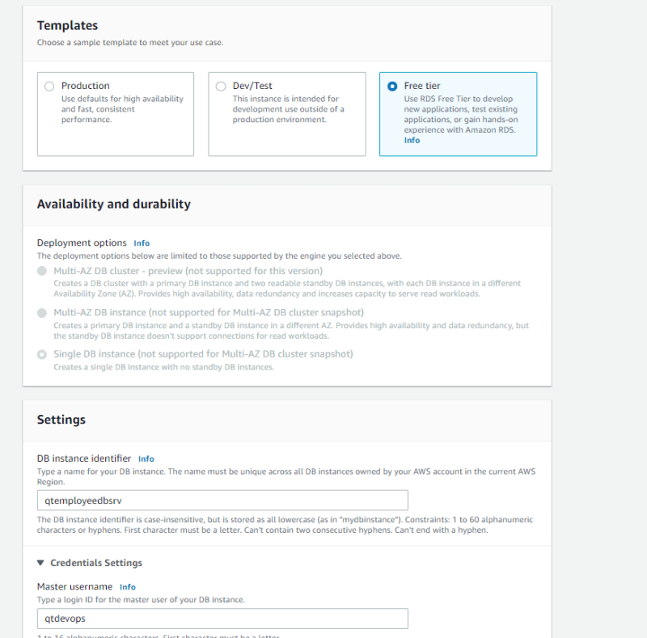  
  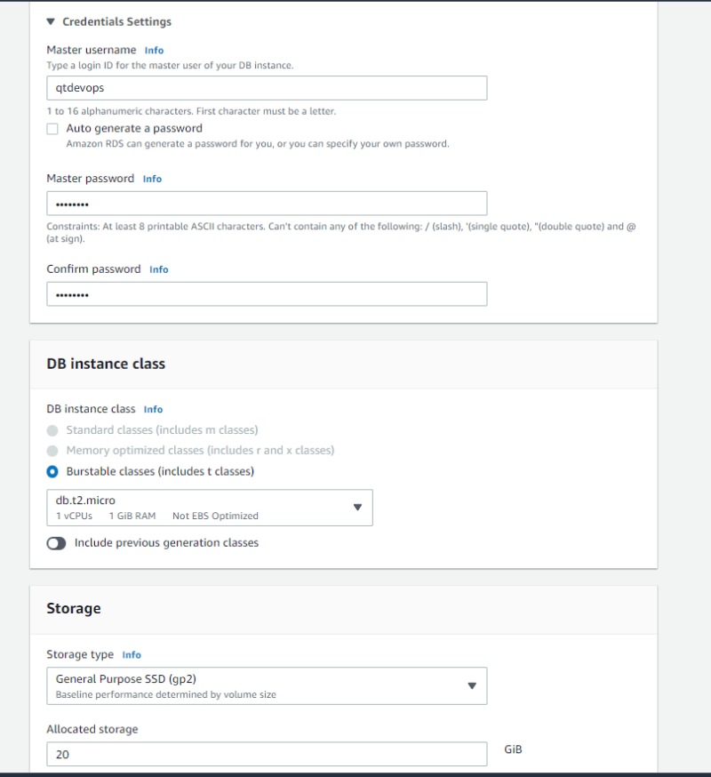  
  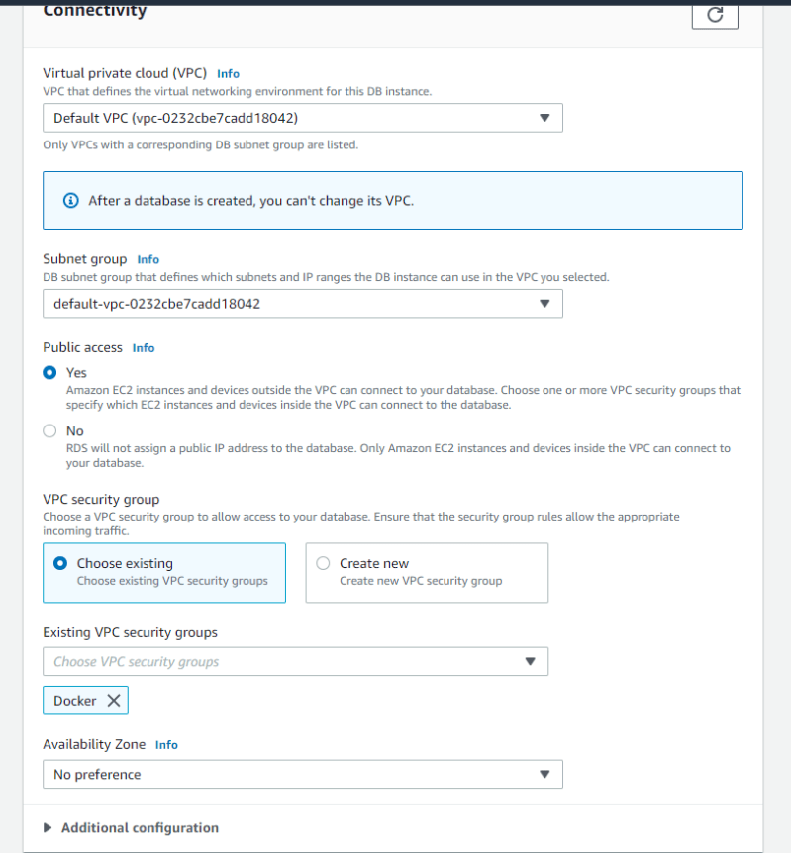  
  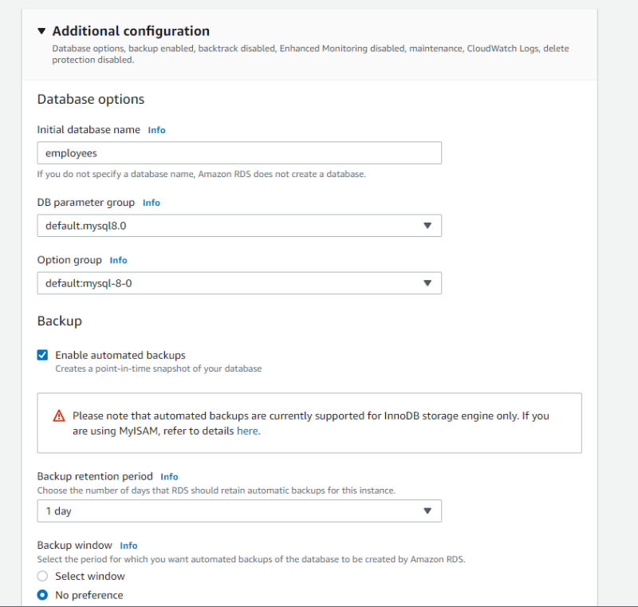  
  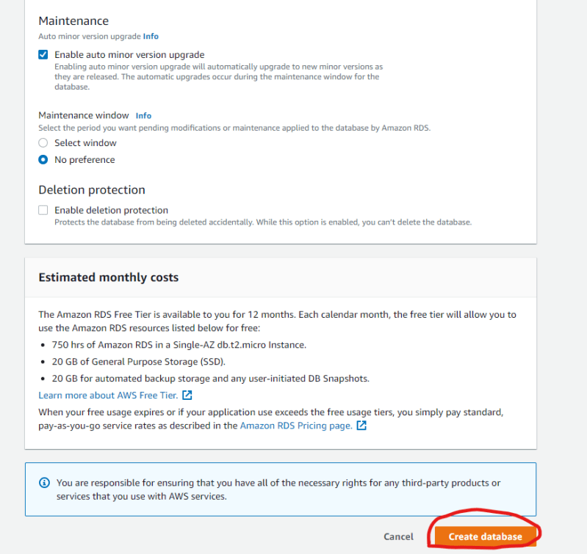  
  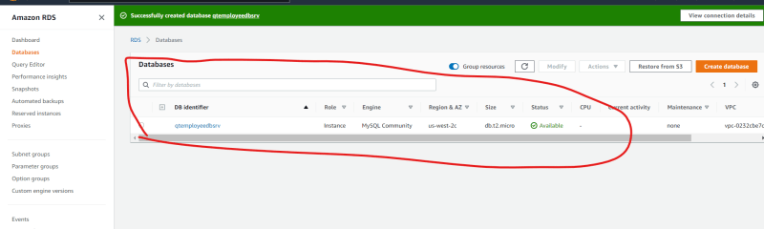

**Endpoints**

* Navigate to the database migration service  
  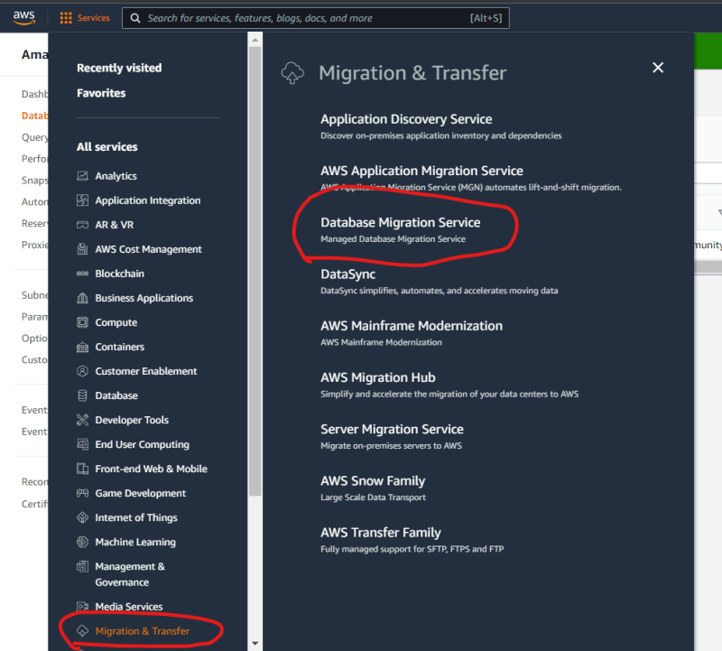
* Lets create a source endpoint which connects to our simulated on-premise db  
  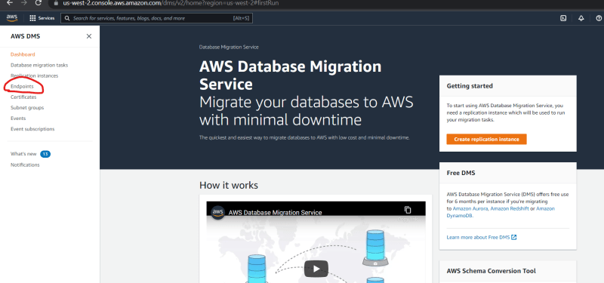  
  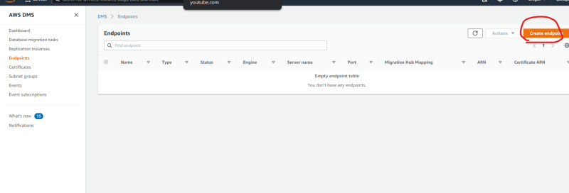  
  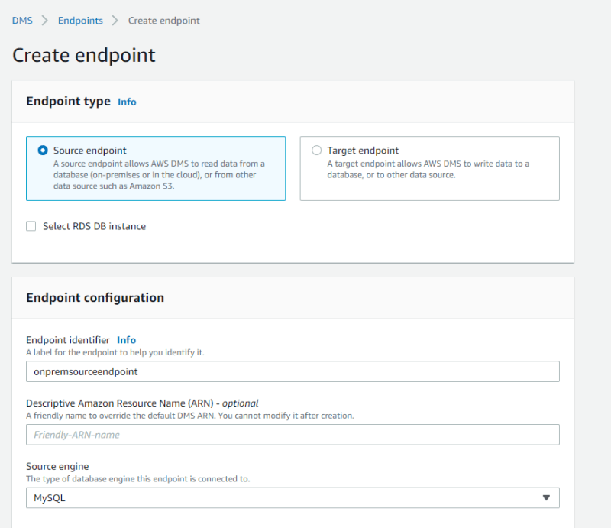  
  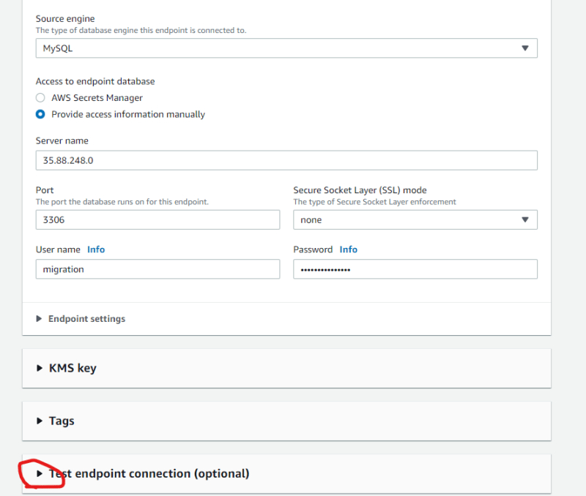  
  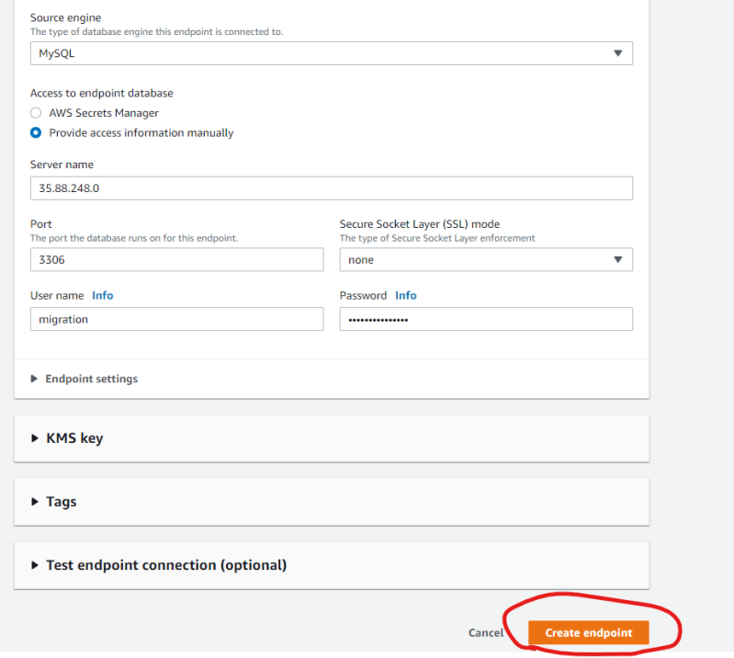  
  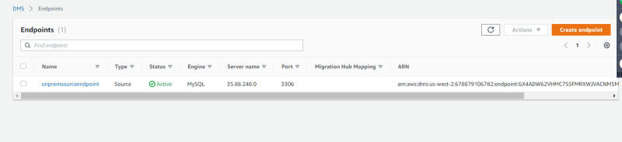
* Now lets create target endpoint  
  